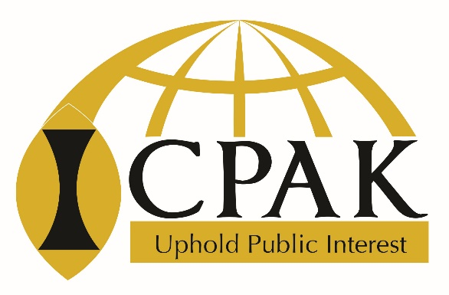

INSTITUTE OF CERTIFIED PUBLIC ACCOUNTANTS OF KENYA

CATEGORY M – ACCOUNTING, CONTROLS AND CONSULTANCY GUIDLINES

RECORDED FEEDBACK FORM
April 2020

Name ……………………………………………………………

 | Issue | Page no. | Proposed change | Justification
1
2
3
4
5
6
7
8
9
10

Expand as you may wish

