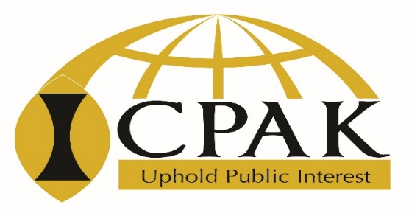

LAUNCH OF MULTIPLE LICENCES
PROGRAMME
DATE 19th NOVEMBER 2020

Session Moderator: FCPA Rose Mwaura – ICPAK Chairman
DATE | TIME | SESSION | FACILITATOR
THURSDAY 18th NOV. 2020 |  | Webinar platform testing | ICPAK – Technical team
THURSDAY  19th November 2020 | 12:00 PM – 12:30 PM | - Introductions and welcoming remarks  - Brief on the Composite licensing | CPA Rose Mwaura, MBS  National Chairman -ICPAK and CPA Edwin Makori  Chief Executive Officer – ICPAK
 | 12:30 PM – 13:10 PM | Presentation on the multiple licenses:  - Category A - Audit and Assurance  - Category T - Tax practice  - Category M – Accounting, Controls and Consultants  - Category C – Composite, includes categories A, T, and M | FCPA George Mokua  National Vice Chairman -ICPAK, and Convener Practitioners Development Committee - PDC
 | 13:10 PM – 13:25 PM | Procedure for applying for the multiple licenses, requirements, and frequency of meetings | CPA Dr. Nebart Avutswa  Chief Manager – Professional Services
 | 13:25 PM – 13:45 PM | Questions and Answers / Discussions by Participants | All
 | 13:45 PM – 13:50 PM | Resolutions and way forward. | CPA Edwin Makori – Chief Executive Officer
 | 13:50 PM – 14:00 PM | Vote of Thanks:  FCPA George Mokua - National Vice Chairman -ICPAK

